**Trip Planner App**

Submitted in partial fulfillment of the requirements

of the syllabus of

Android Apps Development Lab

in

Information Technology

by

Atharva Deshpande 118A3009

Dharani Arikrishnan 118A3011

Sairam Iyengar 118A3018

Under the Guidance of:

Ms. Bushra Shaikh



Department of Information Technology

SIES Graduate School of Technology

2021-22

**CERTIFICATE**

This is to certify that the project entitled **“Trip Planner App”** is a bonafide work of the following students, submitted to the University of Mumbai in partial fulfillment of the requirement of the syllabus of **Android Apps Development Lab** in **Information Technology.**

Atharva Deshpande 118A3009

Dharani Arikrishnan 118A3011

Sairam Iyengar 118A3018

Ms. Bushra Shaikh Dr. Lakshmi Sudha Dr. Atul N Kemkar

Internal Guide Head of Department Principal

**PROJECT REPORT APPROVAL**

This project report entitled ***Trip Planner App*** by following students is approved for the requirement of the syllabus of ***Android Apps Development Lab*** in ***Information Technology.***

Atharva Deshpande 118A3009

Dharani Arikrishnan 118A3011

Sairam Iyengar 118A3018

**Name of External Examiner: --------------------------------**

**Signature:--------------------------------**

**Name of Internal Examiner: --------------------------------**

**Signature:--------------------------------**

**Date:**

**Place:**

**DECLARATION**

I declare that this written submission represents my ideas in my own words and where others’ ideas or words have been included, I have adequately cited and referenced the original sources. I also declare that I have adhered to all principles of academic honesty and integrity and have not misrepresented or fabricated or falsified any idea/data/fact/source in my submission. I understand that any violation of the above will be cause for disciplinary action by the Institute and can also evoke penal action from the sources which have thus not been properly cited or from whom proper permission has not been taken when needed.

Atharva Deshpande 118A3009

Dharani Arikrishnan 118A3011

Sairam Iyengar 118A3018

Signature __________

Date: __________

**ACKNOWLEDGEMENT**

It gives us immense pleasure to thank Dr. Atul N Kemkar, our Principal for extending his support to carry out and develop the project. We also thank our Head of Department Dr. Lakshmi Sudha for her support in completing the project. We wish to express our deep sense of gratitude and thank to our Internal Guide, Ms. Bushra Shaikh for her guidance, help and useful suggestions, which helped in completing our project work in time.

We would like to thank the entire faculty of Information Technology Department for their valuable ideas and timely assistance in this project, last but not least, we would like to thank our non-teaching staff members of our college for their support, in facilitating timely completion of this project.

**Project Team**

Atharva Deshpande 118A3009

Dharani Arikrishnan 118A3011

Sairam Iyengar 118A3018

**ABSTRACT**

In order to make the trip more enjoyable and better experience we need to organize the things that we would be doing in the trip. Our Application helps the user not only to organize the things that he/she would be doing on the trip but also to navigate the location where the user wants to go. This is an android based application which is developed using Java programming language. Similarly, to handle all the back end programs and data storage SQLite database is used. It is developed in Android Studio 3.3.2 IDE. We have worked with Google Maps API which navigates the location of the user and destination places. It is a totally user-based system.

**Contents**

|  |  |  |
| --- | --- | --- |
|  |  | **Page No.** |
| **Chapter 1** | **Introduction** | **8** |
| **Chapter 2** | **Survey of Existing Apps** | **9** |
| **Chapter 3** | **Report on Present Investigation** | **10** |
|  | 3.1 Problem Statement | **10** |
|  | 3.2 Source of Problem Statement | **10** |
| **Chapter 4** | **Design and Implementation of Android Apps Components** | **11-13** |
|  | 4.1 Layouts | **11** |
|  | 4.2 Intents | **11** |
|  | 4.3 Activity | **11-12** |
|  | 4.4 Database | **12** |
|  | 4.5 Camera | **13** |
|  | 4.6 Location API | **13** |
| **Chapter 5** | **Report on Proposed System and its Implementation** | **14-15** |
|  | 5.1 Block Diagram | **14** |
|  | 5.3 Hardware | **15** |
| **Chapter 6** | **Results and Discussions** | **16-19** |
|  | 6.1 Summary of Screenshots with Navigational Flow | **16-19** |
| **Chapter 7** | **Conclusions** | **20** |
| **References** |  | **21** |

**Chapter 1**

**Introduction**

In order to make the trip more enjoyable and better experience we need to organize the things that we would be doing in the trip.

Our Application helps the user not only to organize the things that he/she would be doing on the trip but also to navigate the location where the user wants to go.

This is an android based application which is developed using Java programming language. Similarly, to handle all the back end programs and data storage SQLite database is used. It is developed in Android Studio 3.3.2 IDE. We have worked with Google Maps API which navigates the location of the user and destination places. It is a totally user-based system.

**Chapter 2**

**Survey on Existing Apps**

**1. Triplt**

## A popular name in the field, [TripIt](https://www.tripit.com/web) (Free) is straightforward in its execution. All you have to do is forward your travel confirmation emails to the service, and the app instantly creates a travel schedule for you. No more having to piece things together yourself. It’ll tell you exactly when you need to be at your flight gate, when the car is ready to pick up from the rental place, and when you’re good to check in at your hotel. It even keeps on top of your restaurant reservations.

## **2.** **Roadtrippers**

[Roadtrippers](https://redirect.viglink.com/?key=204a528a336ede4177fff0d84a044482&u=https%3A%2F%2Froadtrippers.com%2F) (Free) is focused on the journey, not just the destination. If you’re driving across the country for a while, odds are you want to stop and smell the roses every once in a while (or maybe smell the [World’s Biggest Ball of Twine](https://www.atlasobscura.com/places/world-s-largest-ball-of-twine)). That’s the thinking behind the Roadtrippers app, which is all too eager to tell you what’s nearby. As you plot out your itinerary, more suggestions come up so you can find the perfect diner on your drive.

**3. Kayak**

[Kayak](https://www.kayak.com/) (Free) is an online travel agency and it excels in finding you great deals on all modes of transportation, though it can also find deals on stays, activities, and travel packages. Simply tell Kayak your preferred modes of transportation—like riding trains, flying or driving a car—and it comes up with all of your options, regardless of where you are, when you want to travel, or what your budget is.

**Chapter 3**

**Report on Present Investigation**

**3.1) Problem Statement:**

Trip Planner App:-

To build a common platform that connects the user with their friends and families to plan for trips.

**3.2) Source of Problem Statement:**

Real user requirement:

In the life of software development, problem analysis provides a base for the design and development phase. The problem is analyzed so that sufficient matter is provided to design a new system. Large problems are subdivided into smaller ones to make them understandable and easy for finding solutions. Same in this project all the tasks are subdivided and categorized.

**Chapter 4**

**Design and Implementation of Android Apps Components**

**4.1) Layouts**

A layout defines the structure for a user interface in your app, such as in an activity. All elements in the layout are built using a hierarchy of View and ViewGroup objects. A View usually draws something the user can see and interact with.

For our application we used a mixture of Constraint layout, linear layout and relative layout for customization of inner components wherever needed.

**4.2) Intents**

Android Intent is the message that is passed between components such as activities, content providers, broadcast receivers, services etc. It is generally used with the startActivity() method to invoke activity, broadcast receivers etc.

We have used Explicit intents to switch between activities and Implicit intents for activities like calling and Camera.

**4.3) Activity**

An activity is a single, focused thing that the user can do. Almost all activities interact with the user, so the Activity class takes care of creating a window for you in which you can place your UI with setContentView(View). While activities are often presented to the user as full-screen windows, they can also be used in other ways: as floating windows (via a theme with R.attr.windowIsFloating set), Multi-Window mode or embedded into other windows.

**Activity Lifecycle :**

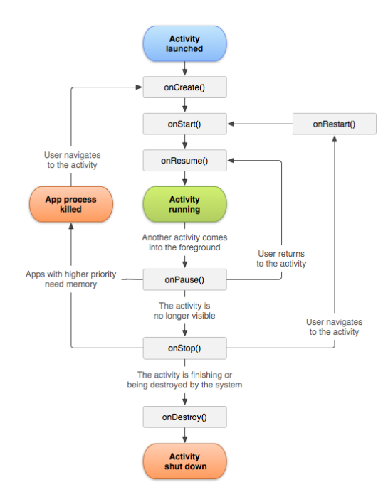

**4.4) Database**

1)We have used firebase for storing and managing our data.

**4.5) Camera**

The Camera class is used to set image capture settings, start/stop preview, snap pictures, and retrieve frames for encoding for video. This class is a client for the Camera service, which manages the actual camera hardware.

We have used camera in our app to set the profile picture of the user.

**4.6) Location API**

One of the unique features of mobile applications is location awareness. Mobile users take their devices with them everywhere, and adding location awareness to your app offers users a more contextual experience. The location APIs available in Google Play services facilitate adding location awareness to your app with automated location tracking, wrong-side-of-the-street detection, geofencing, and activity recognition.

We have used Location Api to get the users and the garage's current location.

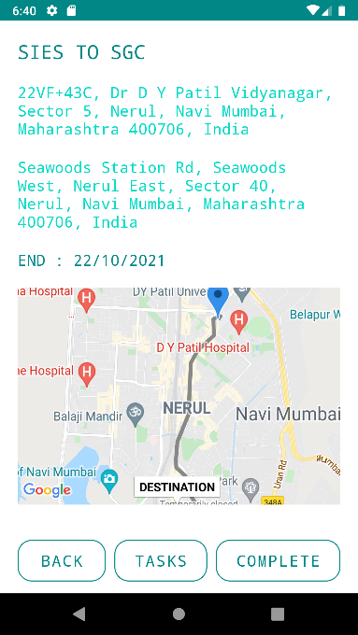

**Chapter 5**

**Report on Proposed System and its Implementation**

**5.1) Block Diagram:**

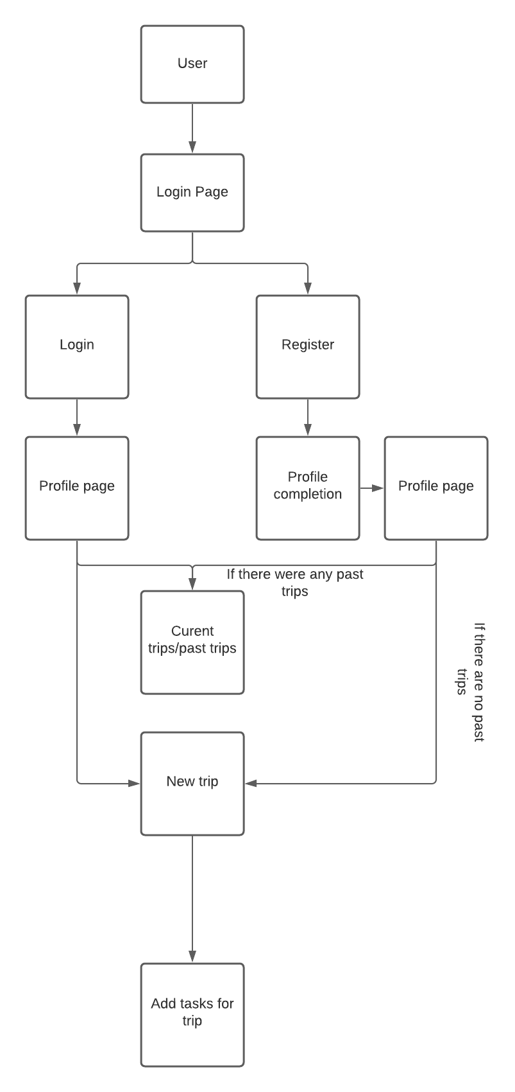

**System Modules:**

**1)User modules:**

1. Login
2. Register
3. Set Location.
4. Create tasks
5. Profile.

**5.3) Hardware Requirements: -**

Processor : Intel(R) 2.10GHz

Installed memory (RAM) : 4 GB

Hard Disk : 160 GB

Operating System : Windows (7)

**Software Requirements: -**

Front-End : Android, Java

Back-End : Node js

Database : Mongodb,Sqlite

Tool : Android Studio

GPS Location : geojson of mongoose, google maps and play services.

Camera : For Profile Picture updation

**Chapter 6**

**Results and Discussions**

**User Module:**

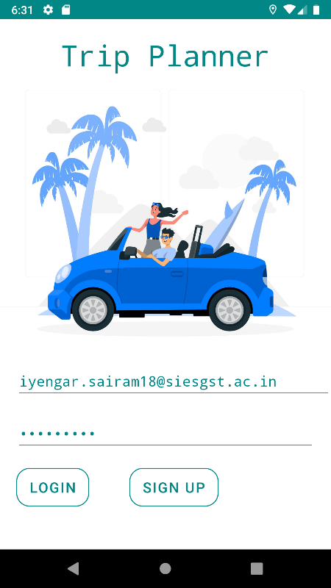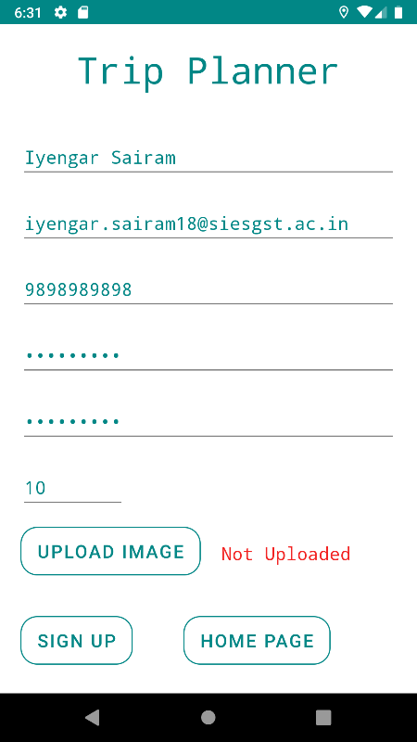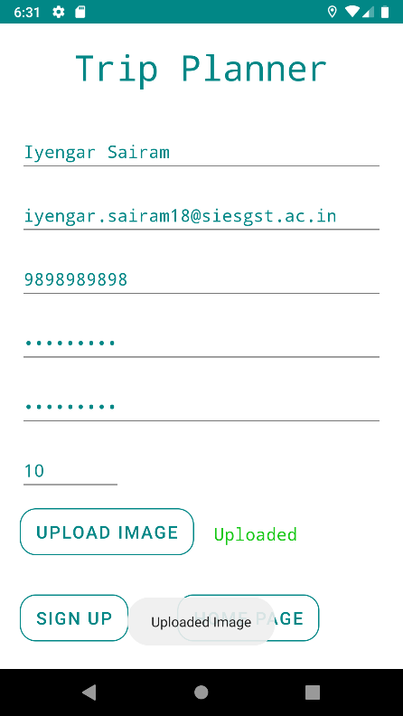

**Fig 0 Fig 1 Fig 2**

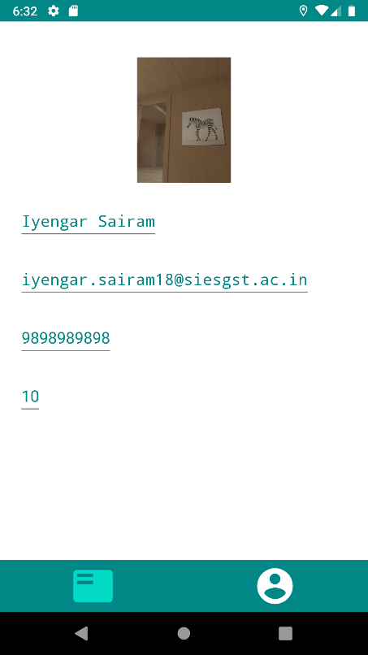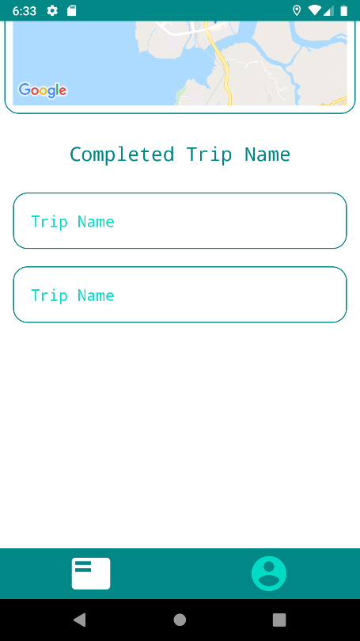

**Fig 3 Fig 4**

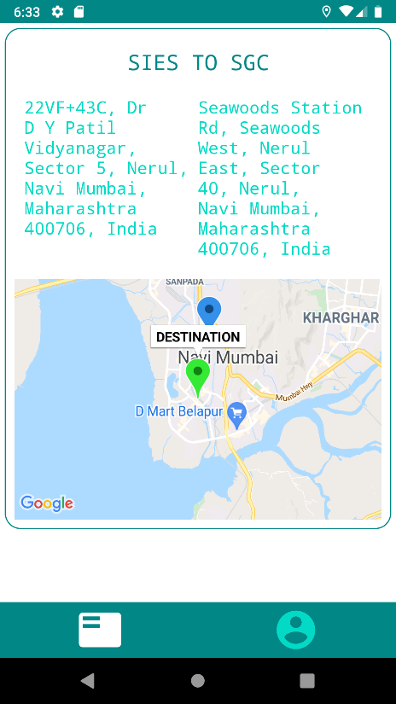 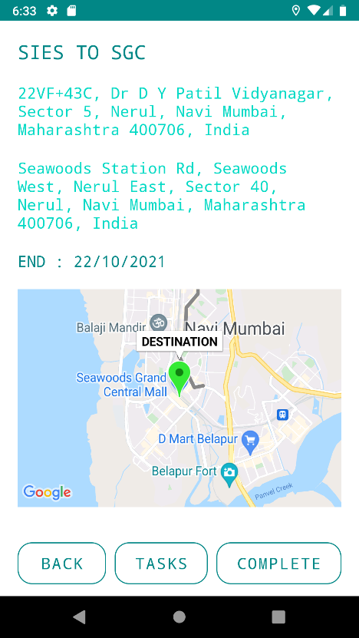

**Fig 5 Fig 6**

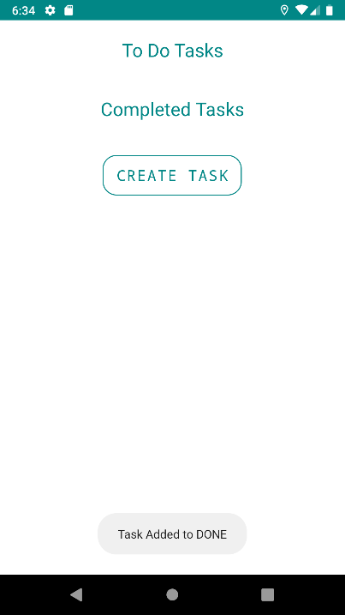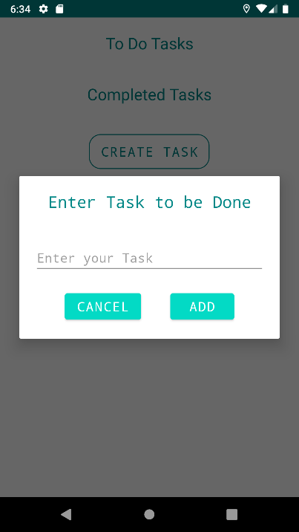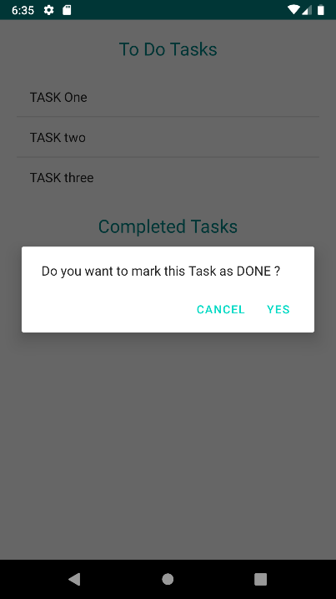

**Fig 7 Fig 8 Fig 9**

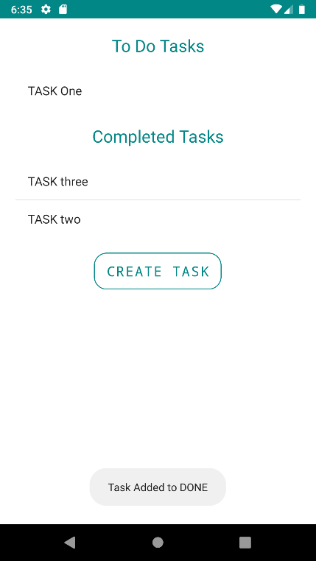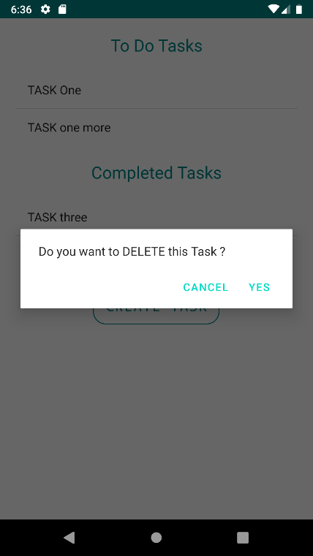

**Fig 10 Fig 11**

After opening the app, A login page would come where the user would be putting the details like Username and password (If the user already has an account) as shown in Fig 0.

If the user doesn't have an account, The user would be creating an account by clicking the registration button which will lead to the page where the user also has an option to upload their image for profile picture as shown in Fig 1.

Once uploaded the application will say that the image has been uploaded as shown in Fig 2.

The user profile is shown as it shown in Fig 3.

After the user gets logged in, A screen would come where the user will be shown his current trip (If he has a current trip) and also the past trips that has been already completed.

If the user don't have any current trip, He can create a new trip using the Google Map in the application. After creating a trip, The user can add tasks that he/she would be doing on the trip.

When the task is completed the user would need to mark the task as completed.

User can create a task as well as delete the task and navigate to the place where he/she wants to go to have a beautiful and organized journey.

**Chapter 7**

**Conclusion**

## 

## **Module Description:-**

The system after careful analysis has been identified to be presented with the following modules **User**

**User**

* **Register** – Users have to register their basic details to get access with this application service.
* **Login** – Once they have registered they need to login to avail the service at the needy time.
* **Set Location** - Once Logged in the user is asked to set their location to view their nearby garages. The location is set with the help of GPSlocation and can be seen in Google maps.
* **Profile -** The user also has an option to view their profile and set a profile photo with the help of the camera.

**Future Scope:-**

In the life of software development, problem analysis provides a base for the design and development phase. The problem is analyzed so that sufficient matter is provided to design a new system. Large problems are subdivided into smaller once to make them understandable and easy for finding solutions. Same in this project all the tasks are subdivided and categorized.

We would be adding an option to book trips using our and the information needed for it would be available for the user. We are also planning to make our app a platform for the user to search for everything related to their trip.

**References**

[1] https://play.google.com/store/apps/details?id=com.tripit&hl=en_IN&gl=US

[2] https://material.io/develop/android

[3] https://square.github.io/retrofit/

[4] https://www.reviewgeek.com/2884/the-6-best-trip-planning-apps-for-headache-free-travel/